Section 3

Problem 2

What will happen when you add two elements with value **41?**

When we add the element with value 41 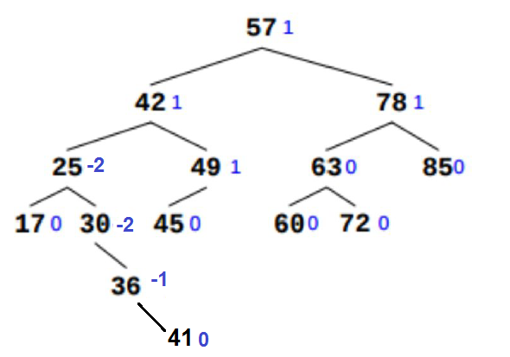

We found that the balance = -2 on the element with value 30 ,the Balance should be between values [-1,0,1]

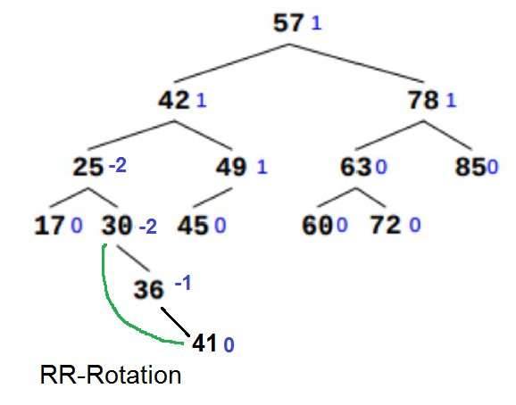

So we will do the RR-Rotation to make it in the Balancing .

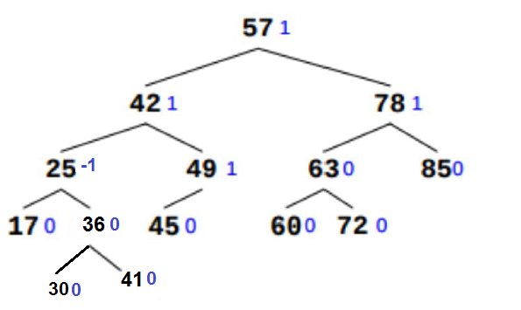

What will happen when you add two elements with value **50?**

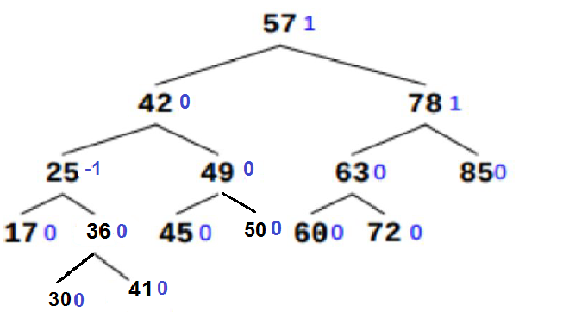

In this case we found the tree in the Balance and no need to any Rotation.

Problem 3

Delete the node with value 42 :

-this node is a leaf, So we replace it with null

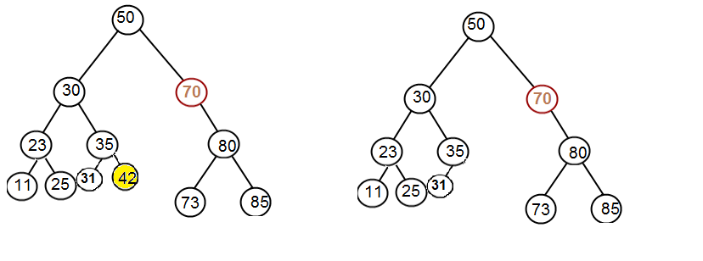Delete the node with value 70

-this node has one child, So we make its parent connect to its child and then we remove the node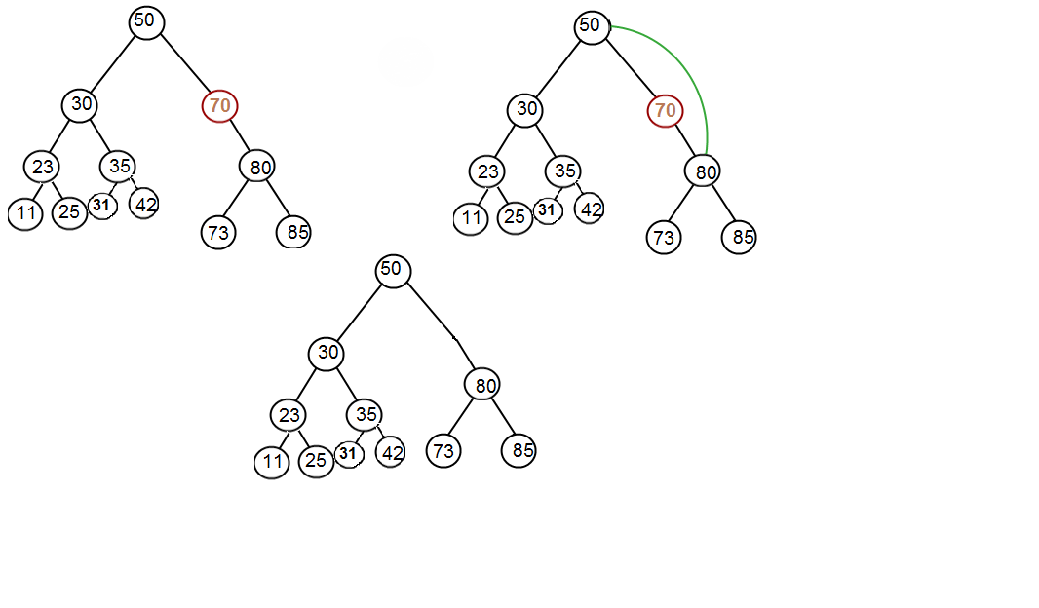

Delete the node with value 30

- the node has two children So we choose to get its successor,get the left most node in the right tree*.*

1. Remove 30 from a BST.
2. Find minimum element in the right subtree of the node to be removed.
3. Replace 30 with 31.
4. Remove 31 from the left subtree.

